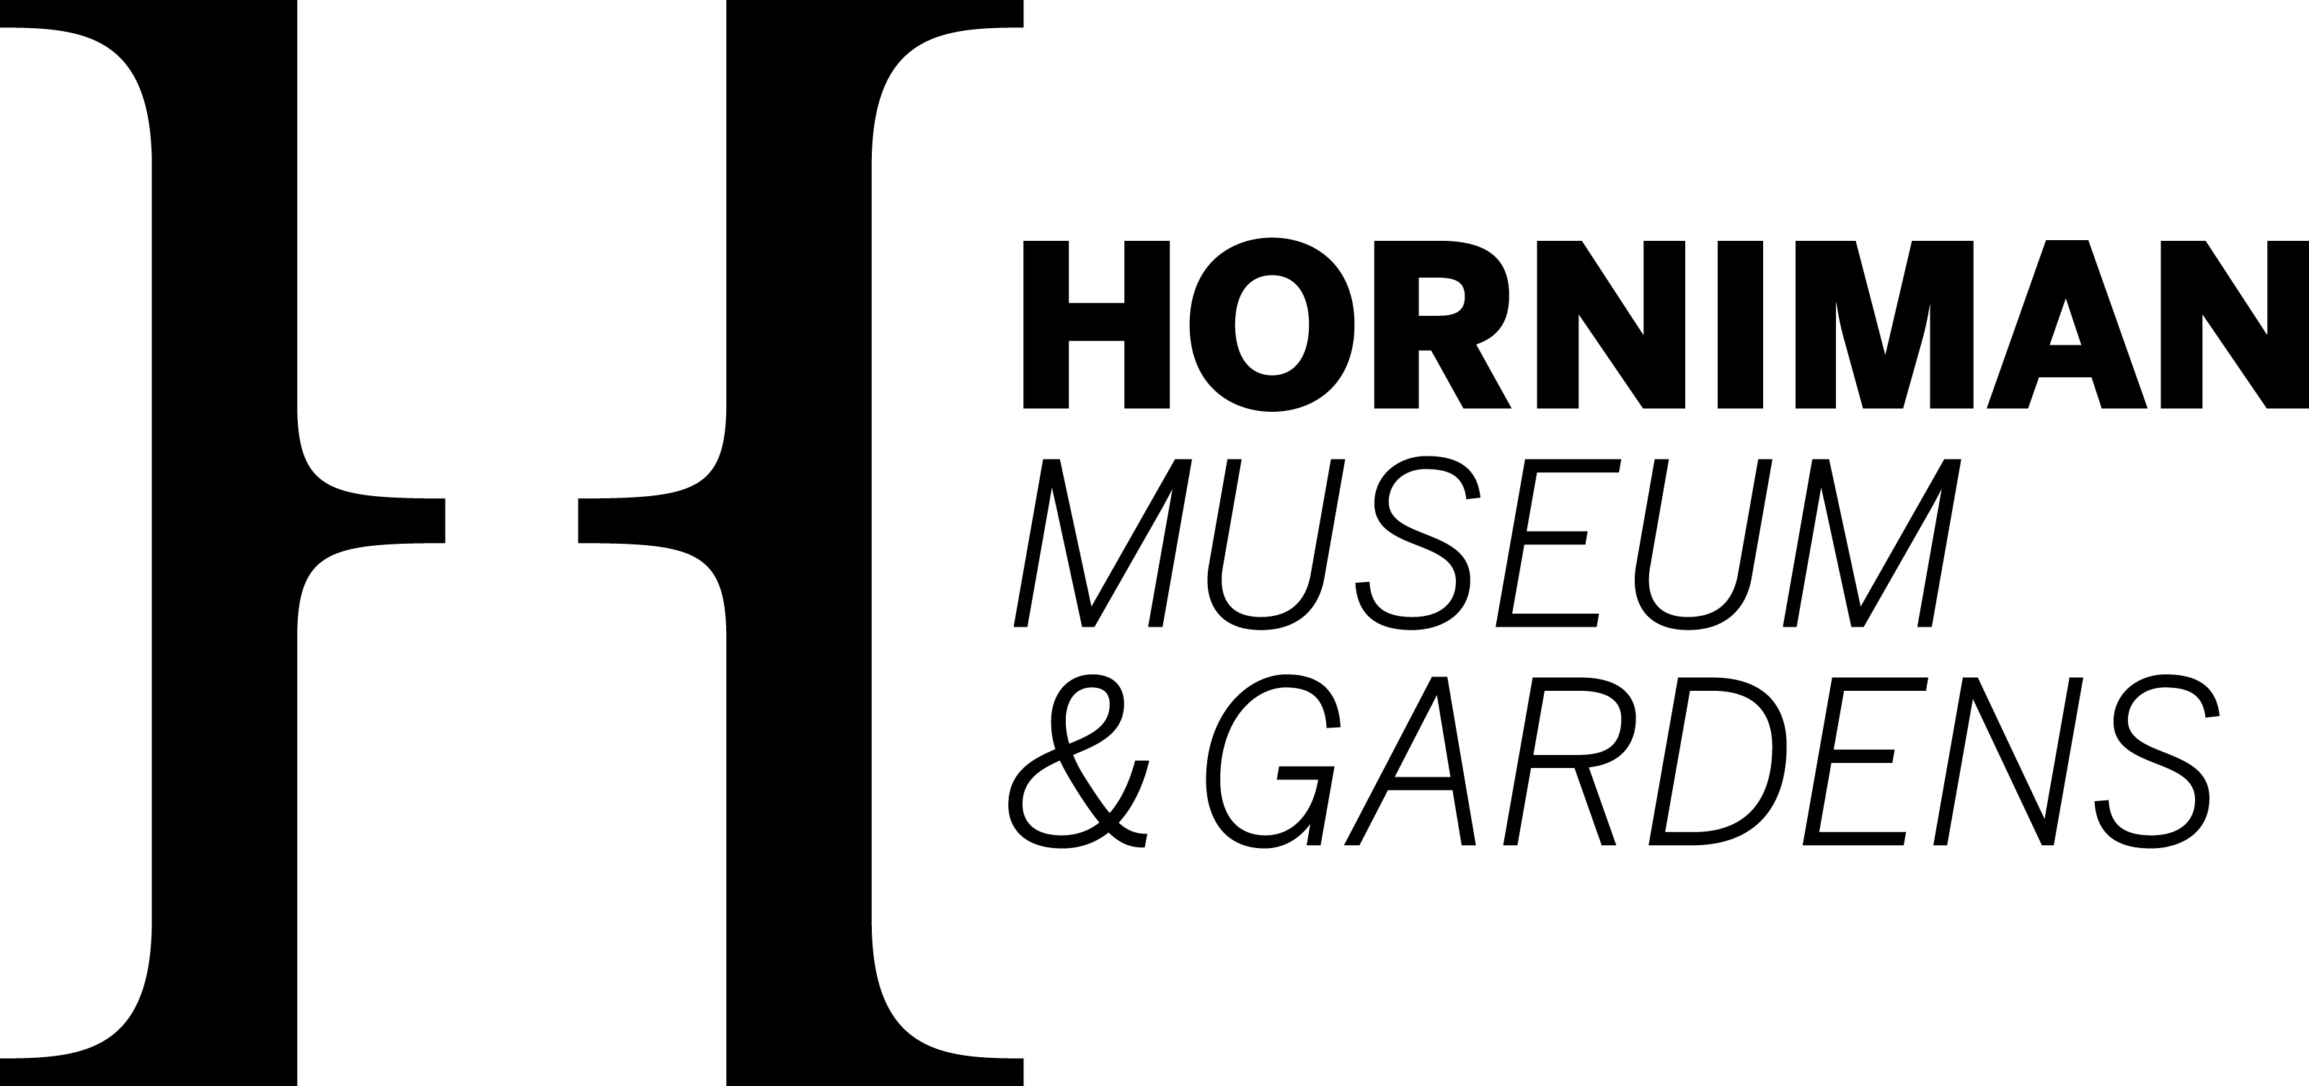

# **Object in Focus: Listening to Objects**

(♪ Music, singing and gong chiming underneath the whole video)

Panning shot of Kayan tattoo models laid in a box

Footage of gongs being hit and a Parap and Takna practitioner speaking into a microphone.

**Adrian Jo Milang in voiceover:** I am the youngest and one of the few remaining practitioners of the Kayan oral traditions known as parap and takna’ from Sarawak, Borneo. The tattoo motifs on these wooden models are part of the Kayan People’s rich culture.

Panning shots of the Kayan Tatoo models

**Adrian Jo Milang in voiceover:** We are one of the many indigenous communities living in Borneo.

Aerial shots of a forest and a boat on some clear blue water.

**Adrian Jo Milang in voiceover:** Because of the advance of the British maritime technology, we were colonised.

Panning shot of ‘materials for a study of tatu in borneo’. A highlighted section can be seen which says ‘the Kayans are, with one or two exceptions the most tatued… perhaps the best tatued from an artistic point of view’

**Adrian Jo Milang in voiceover:** About 100 years ago, to study our culture, they collected such models

Panning shots of Kayan Tatoo models

**Adrian Jo Milang in voiceover:** Sometimes, they were lost in translation. Tattoos play a big part in our culture, heritage and tradition, especially for womenfolk.

Images of examples of these tattoos

**Adrian Jo Milang in voiceover:** In fact, the keepers of our knowledge on tattoos are only a few elders and tattooists blessed by ancestral spirits.

Image of Evak Ngo

**Adrian Jo Milang in voiceover:** My late Great-Grandmother Evak Ngo was the last known master in our community. And our culture is far beyond the motifs can present.

Footage of Adrian Jo Milang and a group singing together.

**Adrian Jo Milang in voiceover:** Kayan Tattoo or Kayan women tattoo as we call it, tedek, is a mother’s gift to her daughter, as well as a symbol of wealth, beauty, status, and a rite of passage of marriage and into womanhood.

Image of tattoos and women with tattoos.

**Adrian Jo Milang in voiceover:** Although some Borneian tattooists still practice hand-tapping methods, for us the Kayan people, our tattooing tradition stopped passing on.

Images of various tattoos

**Adrian Jo Milang in voiceover:** Colonial impact was one of the factors, apart from the introduction of new religions, modern cultures, an already dwindling interest in the culture artform.

Images of Adrian Jo Milang

**Adrian Jo Milang in voiceover:** Any culture will change wih time, but should never die out.