**Welcome to the Horniman Museum and Gardens for our Twilight relaxed opening.**

We hope you enjoy your visit to our new **Dinosaur rEVOLUTION** exhibiton.

We have also included information about the other galleries that will be open.

Here’s a little bit of information about what to expect:

Dinosaur animatronic




Highlights a change in light levels



Highlights noisy areas

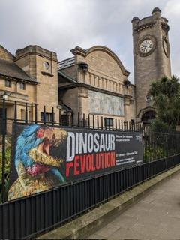

This is what the Horniman Museum looks like.

You can see the Clocktower as you approach the Museum.

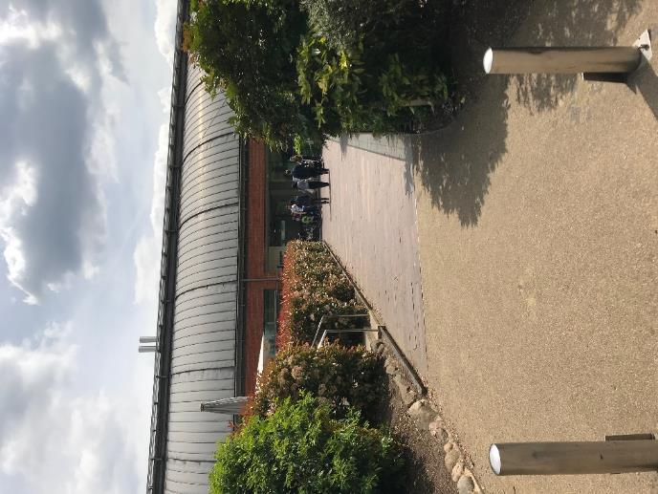 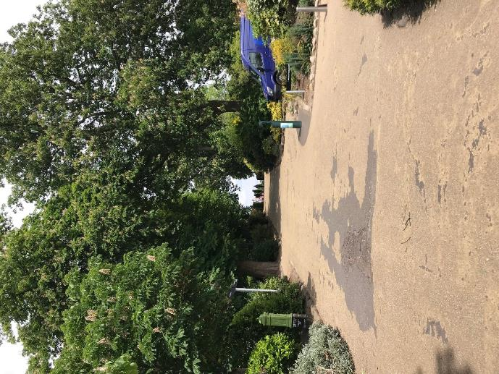

You can walk up the avenue and then right into the Museum up the ramp.

You might see a van like this one making a delivery to the museum.

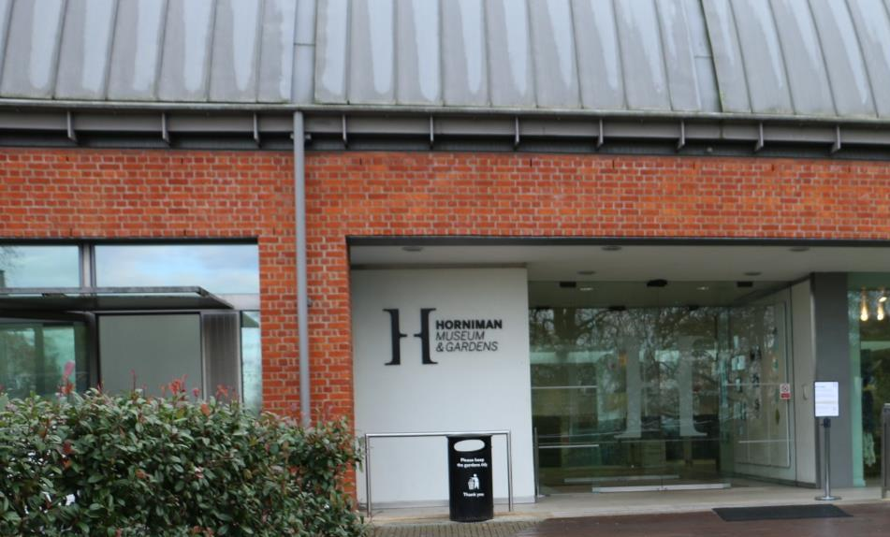

This is the entrance to the Museum. You go through two automatic glass doors.

The museum will open promptly at 6pm. There are places to wait outside the museum if you are early.

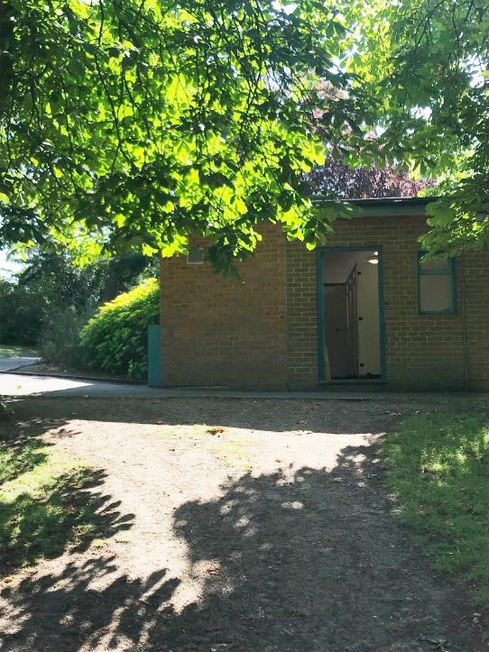

There is a toilet block in the garden which will be open until the gardens close which is currently at 7:30pm.

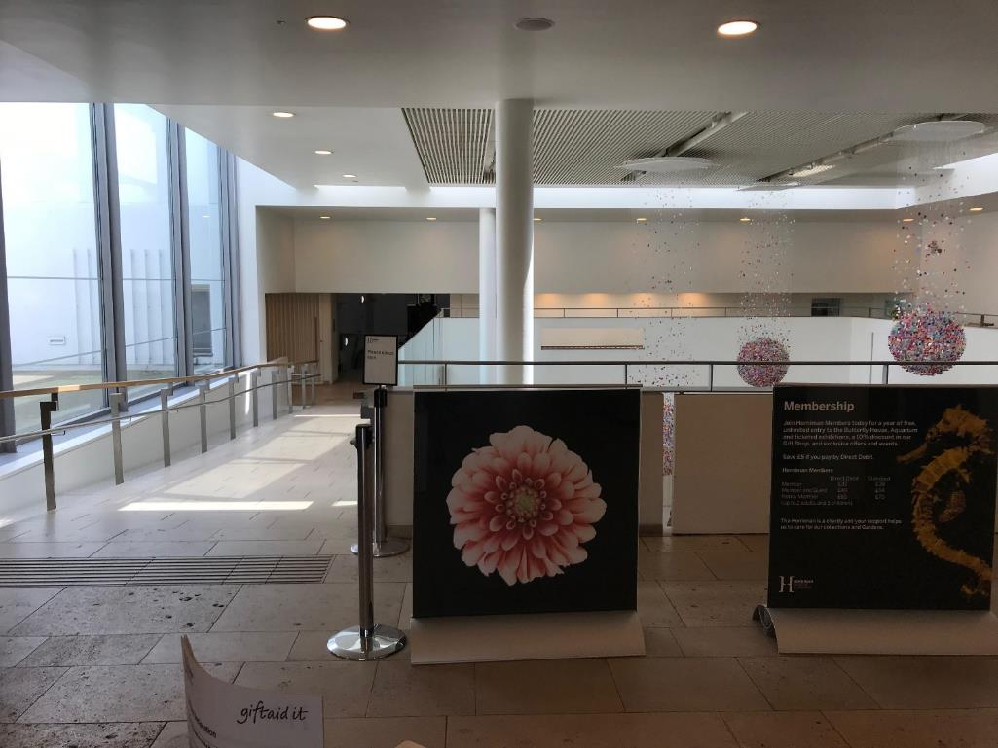

This is what you will see in the main entrance.

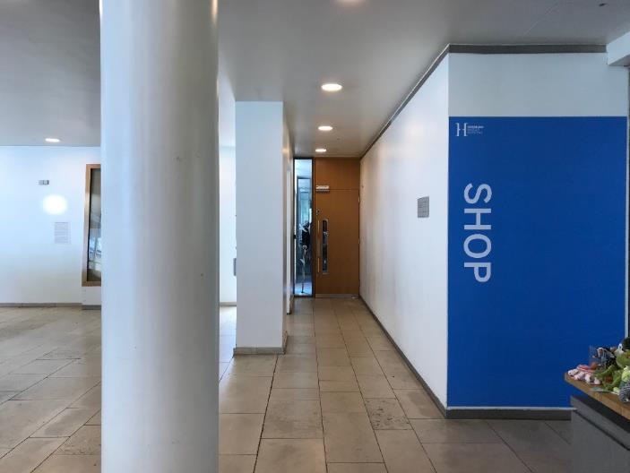 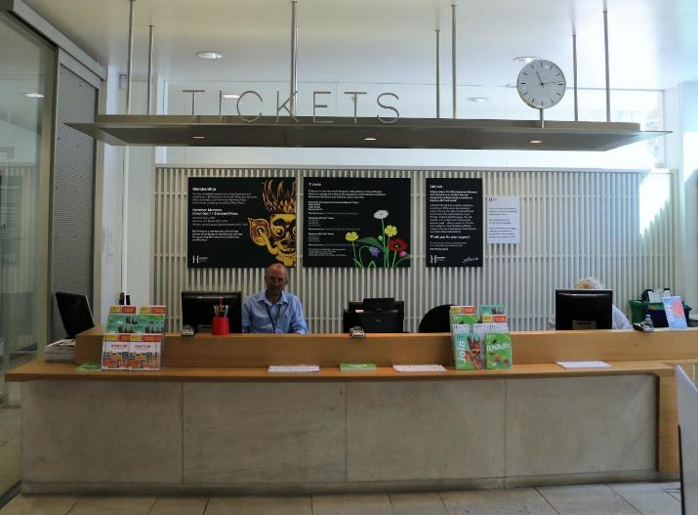

Just inside on the left you’ll see the ticket desk. Our friendly staff, like Tony, are waiting to help you enjoy your visit.

On your right is a door to a Chill Out space.

You can relax in our pop-up tent, play with some toys or maybe eat or drink something you have brought with you.

There are also toilets nearby.

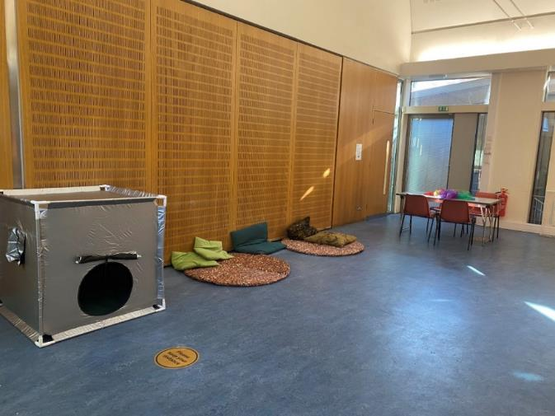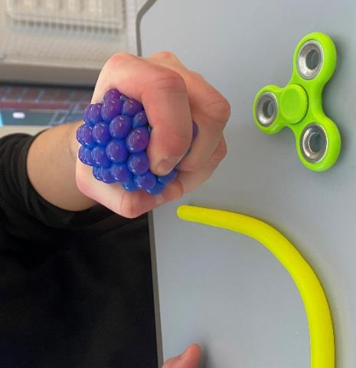

The Chill Out space is open until 7pm.

Horniman staff are happy to help if you need anything.

 

To get to the **Dinosaur rEVOLUTION exhibition** you could take the stairs, or the lift – whichever you prefer.

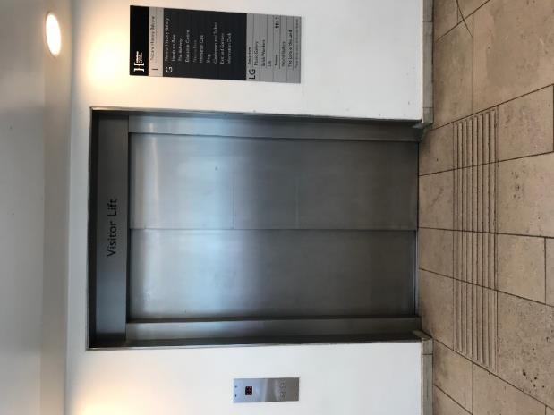 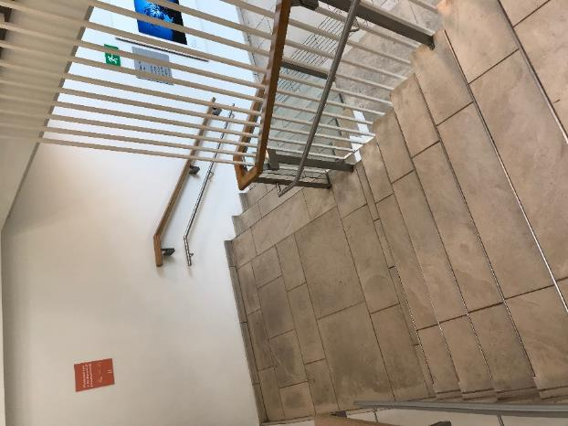

Stairs

Lift

If you arrive downstairs via the lift, **Dinosaur rEVOLUTION** will be immediately to your right as you come out of the lift.

If you come down the stairs then **Dinosaur rEVOLUTION** will also be to your right.

A door with a poster on it


The area in between the two exhibitions is called Gallery Square.

There are some toilets off Gallery Square. We will turn off the hand dryers in the toilets.

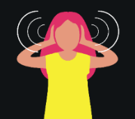 This is a big open space and there may be a little bit of noise as people are arriving for **Dinosaur rEVOLUTION.**

You may also see some people cleaning the Museum.

**Dinosaur rEVOLUTION Exhibition**

It is a little darker inside **Dinosaur rEVOLUTION** than outside in Gallery Square. It is also a little cooler with the air conditioning, which you might hear as well as feel.

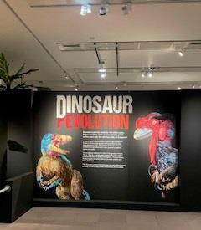

This is what you will see as you enter the exhibition.

If you turn left you will start at the beginning of the exhibition.

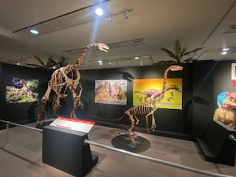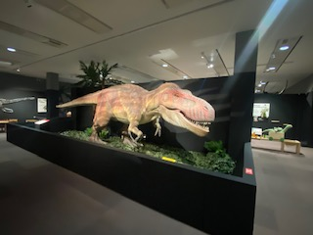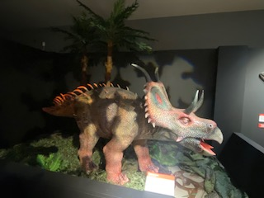

There are lots of models of dinosaur skeletons in the exhibition.

Our main lights are turned down low but some of the models have spotlights.

This means that you can see them up close, but the spotlights can be quite bright.

Some of the models also move and make noises when you walk past them.

We have turned the sound down on these models.

If the noise is still too loud, please let a member of staff know and we’ll turn it off for you.

The models might look big and tough but they can easily break, particularly the teeth and tails!

Have fun watching them but don’t get too close or touch them.

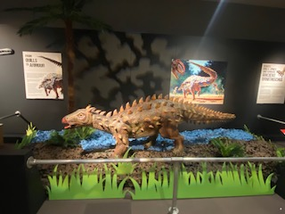

Some of the models have loose parts, like the fake grass.

Remember to stay behind the barriers so that you don’t accidentally knock anything over.

If you do knock anything by mistake, just let a member of staff know and they’ll fix it.

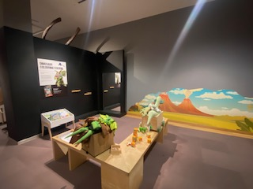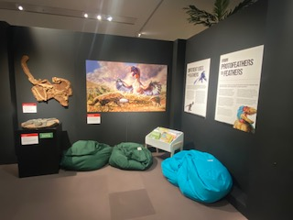

There are a few different places inside the exhibition where you can stop to play or rest.

There are toys to play with and costumes to dress up in.

We hope you have fun exploring all of these areas.

When you are finished having a look around the exhibition you can explore some of the other galleries.

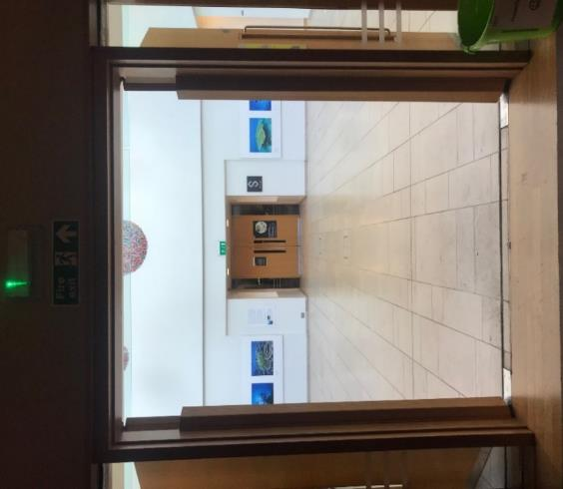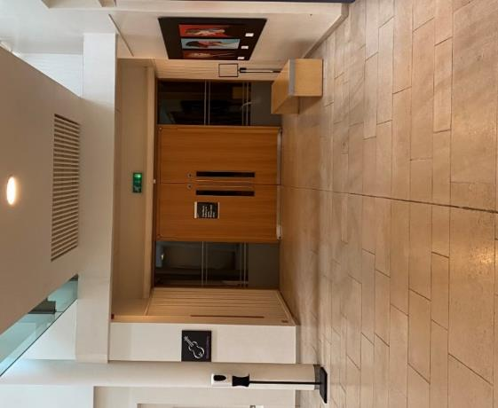



Remember when you come out into Gallery Square it may seem a little bright.

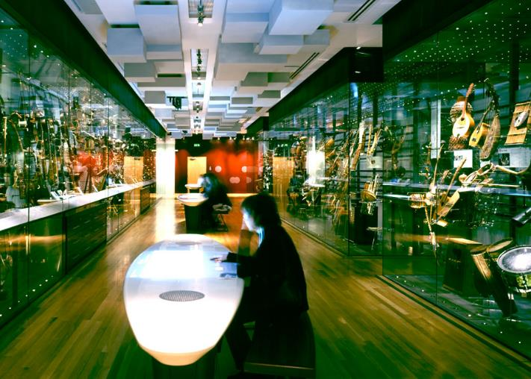

The Music Gallery is just on your right when you come out of the **Dinosaur rEVOLUTION** exhibition.

It is a little darker inside this gallery than outside in Gallery Square. It is also a little cooler with the air conditioning, which you might hear as well as feel.

There are lots of instruments to look at and you can also listen to some of them on our sound tables.

If you turn left when you come out of **Dinosaur rEVOLUTION** and walk through Gallery Square you can go down to our Aquarium. You can either go down the stairs or take the lift.

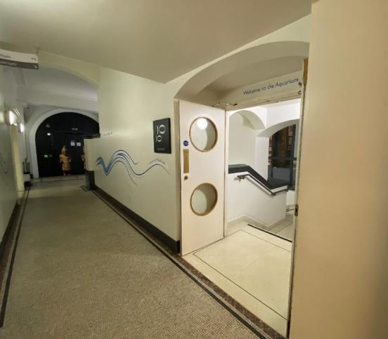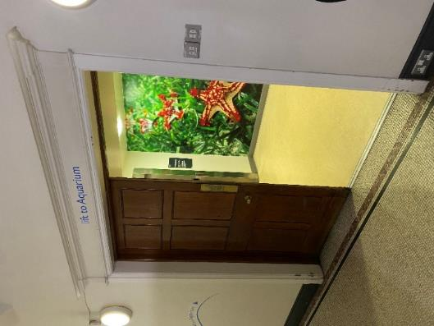

The lift is a little further along the corridor on the left

Stairs

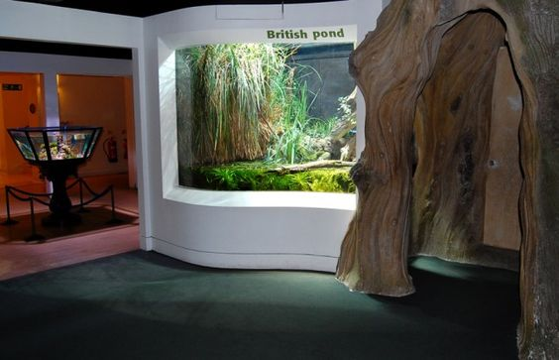

Although the lights are turned down a bit in the Aquarium, all of the tanks have their own lighting so it is still quite bright.

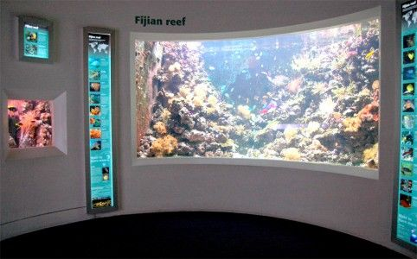

Our Aquarium might be small but you can see fish and other water creatures from different parts of the world.

Our World Gallery is also on the same level as **Dinosaur rEVOLUTION,** just turn left when you come out of the exhibition and then take your first right (just opposite the lift that takes you back upstairs).

We usually have lots of films playing in this gallery, but we will turn them off for this early session so it is quieter.

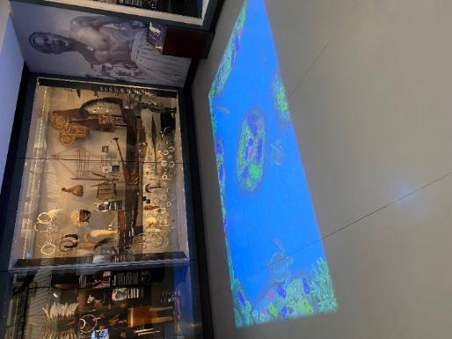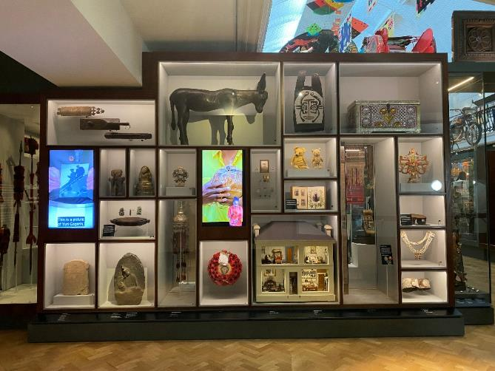

You can still watch the underwater projection on the floor in our Oceania encounter and follow the fish across the floor.

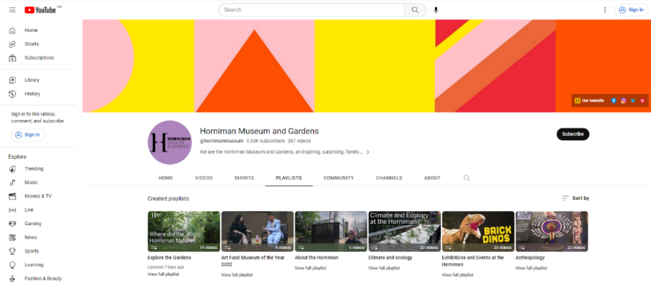

If you want to watch more videos that show you how to get to the Museum or walk to different parts of the Museum and Gardens then we have more films on our YouTube playlist ‘[Watching the Route’.](https://www.youtube.com/playlist?list=PLVLBYq1ay8T61ySxW8RZGoW56W718GDUW)

Remember you can go back to the chill out room whenever you want.

You can have a drink or eat something in there. The chill out room closes at 7pm.

We hope you enjoy your visit.